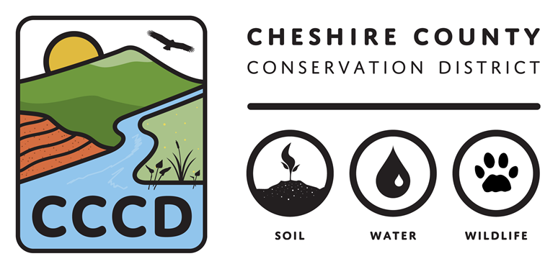
2023 Conservation Opportunity Fund
Application Form

Before completing this application, please carefully review the Request for Proposals (RFP), which is available at www.cheshireconservation.org/conservation-opportunity-fund
Please call 603-756-2988 ext.4 if you have questions when completing this application.

Applicants must answer all questions fully to be considered for funding. Applicants must use the application form or their application will not be considered for funding.

Only submit an application if you check YES to all of the following criteria

Primary Criteria | NO | YES
You are a qualified applicant – a landowner of less than 25 acres total in Cheshire County, NH that is interested in improving the wildlife habitat on their property
The project activities are listed in the eligible activities list in the RFP or have been pre-approved by the Conservation District.
The project will be completed, and all grant funds spent by December 31st of the year of the grant award.
The project has not been started and will not begin until it is selected for funding and there is a site visit with the Conservation District to review plans and provide advice for the successful completion of the project.

Applicant Information
Applicant Name:
Applicant Mailing Address:
Contact Person:
Phone:
Email:
Project Information
Project Type:
Project Location:
Grant Amount Requested:
Size of Project (acres or square feet):

Project Narrative – 1,000 word maximum

The narrative must address the following items. Please answer questions directly and in order below.

- Please briefly describe your project.

- What are the expected outcomes of your project?

- What are the activities/tasks you will complete to reach your outcomes? Please provide details on the anticipated site preparation that will be necessary for any planting projects.

- The Conservation District is here to provide technical assistance to ensure the success of your project. What guidance would be most helpful to you?

- Please briefly describe what skills and resources (e.g. long-time gardener, water sources for planting success, etc.) you have to successfully complete this project?

- What is your plan for long term maintenance and sustainability of your project?

- What education are you interested in doing as part of this project? (e.g. offering workshops in partnership with CCCD, writing a blog post for CCCD newsletter/website, offering content for CCCD social media, etc)

Budget Table and Budget Justification Narrative

The total budget request can not exceed $1,500.

Please summarize your anticipated project costs in the table below.

Allowable expenses: plant materials and site preparation materials
Expenses not allowed: landowner hours
Budget Item |  |  |  |  | Total Amount
TOTAL EXPENSES

- Please briefly describe each budget item.

- What time and funds do you anticipate committing to this project? Please briefly explain.

Submission

Applicants should submit the following items in support of their application:

- Project Application – including narrative and budget
- Project map – one hand drawn or digitally composed map of your planned activities. (e.g. show on a map where you plan to install the pollinator habitat)
- Photos—One or two photos of the project site (jpgs)

Completed applications must be received no later than 5 p.m. on February 1, 2023. Completed applications may be submitted electronically to amanda@cheshireconservation.org . Completed applications may also be sent by mail, and must be postmarked no later than February 1, 2023. Mail applications to: Conservation Opportunity Fund, Cheshire County Conservation District, 11 Industrial Park Dr, Walpole, NH 03608. All grant applicants will be notified of selection results in early March 2023.

Further questions and/or references may be requested upon committee review.

By submitting this application, if approved, you give the Cheshire County Conservation District permission to announce the grant award through area media sources and publicize you or your organization as a recipient of a Conservation Opportunity Fund grant in promotional material. Access to the application and supporting materials will be provided to the review committee.

